

**TOMATO & BASIL BRUSCHETA**

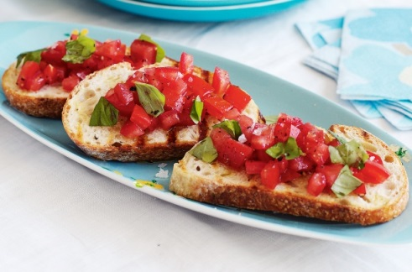

Bowl of tomato’s all different shapes and colours

Big bunch of fresh basil

1 red onion

2 clove of fresh garlic

1 large bread stick

Olive oil

Salt & pepper

Olive oil

**Method**

1. Cut the bread stick into thin slices & toast lightly.
2. Crush garlic and rub the sides of the toasted bread with the garlic.
3. Cut the tomatoes into small pieces & place in a large bowl with the chopped basil and finely diced red onion.
4. Season with salt and pepper.
5. Add in a couple of tablespoons of olive oil, the balsamic vinegar and use your hands to coat.
6. Lay out the toasted bread on plates and flat platters and spoon the tomato and basil evenly over bread.